

ASSET VERIFICATION AND RECORDING TOOL KIT


Plot 31, Bukoto Street
P.O Box 7657, Kampala, Uganda
+256 (0) 39 2000216/0772525235
email: cpa@cpa.ug

www.cpa.com

August to September 2026

VERIFICATION DETAILS

NAME OF THE REGION: | WESTERN
SUB-REGION: | TOORO
Name of Local Government | KABAROLE
VERIFIER PARTICULARS
Full name | ZALWANGO MARIA, NASSEJJE NADIA, NABBOSA SUMAYA
Contact/ email and Telephone | 0751977570/ 0754884004/ 0708098456
Supervisor/ Sub team leader
Name | DEPAUL MBONIGABA
Contact | 0788483159
Date of submission

HEALTH CENTRES
INFORMANT INTERVIEW/DISCUSSION GUIDE (INCHARGE OR RESPONSIBLE PERSON)

Name of Health Centre: NYAMBUSA HEALTH SENTRE III

1a | Does the Facility have a record of all assets provided under UgIFT.  (Obtain a record and verify if it has the costs and numbers supplied
1b | If Not ask how many were supplied and when.

2 | How does this facility Maintain (repair/service/replace) the assets provided under Ugift

3 | Does the facility take regular record about functionality/ or breakdown of the assets provided?

4 | How has the UgIFT support helped in service delivery in the area, any issues, challenges and any recommendations for better program implementation.

Challenges
Most items were broken

PROCEED TO VERIFICATION AFTER THIS DISCUSSION

Health centre checklist

NAME OF LG: KABAROLE DISTRICT NAME OF HEALTH FACILITY: NYAMBUUSA HEALTH CENTRE III

Equipment/ Item | Department | Asset Number | Item  Description | Life in Months | Tag Number ( engrave no.) | Date Of Purchase | Date Placed In Service | Recoverable cost | Cost | Acc Dep Cost | Net Book Value | Ytd Deprn | Equipment status | Remarks
B.P. Machine, Digital
B.P. Machine (Aneroid wall mounted)
Autoclave 20 Liters.,Duo Operated | Health |  | Silver and black in colour |  |  |  |  |  |  |  |  |  | Good condition | 2 still in store.
Bowl, Kick
Bowl Stand
Counting chamber Neubauer- Improved
Cupboard Steel, Lockable | Health |  | Grey in colour |  |  |  |  |  |  |  |  |  | Good condition | Still in store
Drip Stand | Health |  | Silver with black wheels |  |  |  |  |  |  |  |  |  | Good condition | 5 Still in store
ESR Stand
Examination Couch | Health |  | Black mattresses |  |  |  |  |  |  |  |  |  | Good condition | Still in store
Examination light,LED
Glucometer
Haemoglobin Meter, Digital
Height Meter | Health |  | White in colour |  |  |  |  |  |  |  |  |  | Good condition | 2 are in use
Instrument Trolley | Health |  | White and silver in colour |  |  |  |  |  |  |  |  |  | Good condition | 7 are still in store
Microscope Binocular
Otoscope
Patient Screen | Health |  | Blue in colour |  |  |  |  |  |  |  |  |  | One faulty others are in good condition | Still in store.
Patient Trolley
Refrigerator, Basic
Stethoscope
Stop Watch
Stretcher | Health |  | Black in colour |  |  |  |  |  |  |  |  |  | Good condition | 2 still in store
Stove, Gas |  |  |  |  |  |  |  |  |  |  |  |  |  | They only have plates
Weighing Scale with Height Meter, Adult | Health |  | White with a screen |  |  |  |  |  |  |  |  |  | Good condition | They are in use
Weighing Scale, Infant | Health |  | White in colour |  |  |  |  |  |  |  |  |  | Good condition | Still in store
Weighing Scale, Toddler
Wheel Chair | Health |  | Black in colour |  |  |  |  |  |  |  |  |  | Good condition | 6 Not in use
Audio Visual Equipment
Medical Waste Bin | Health |  | Silver in colour |  |  |  |  |  |  |  |  |  | Good condition | Some are in use the rest still in store.
Wall Clock
Diagnostic Equipment Set for MCH
Diagnostic Equipment Set for OPD
Glassware Set, Laboratory, Basic
Hollow Ware Set, Treatment
Instrument Set, Dressing
Instrument Set, Basic ENT
Instrument Set, Suture
Pulse Oximeter, Hand held | Health |  | White in colour |  |  |  |  |  |  |  |  |  | Good condition | Still in store
Bed, Adult Patient with Mattress
Bed, Pediatric Patient, With Mattress
Bedside Locker | Health |  | Grey in colour |  |  |  |  |  |  |  |  |  | Some are faulty and others in good condition | 13 still in store
Cupboard, Instrument | Health |  | White in colour |  |  |  |  |  |  |  |  |  | Good condition | 5 still in store
Delivery Bed, Hydraulic Manual
Oxygen Therapy Apparatus, Mininum 45L cylinder
Resuscitator Manual, Infant, with all Mask sizes
Resuscitator Manual, Adult, with all mask sizes
Suction Apparatus, (Electric) | Health |  | White in colour |  |  |  |  |  |  |  |  |  | Good condition | 1 Not in use
Nebulizer, Ultrasonic | Health |  | White in colour |  |  |  |  |  |  |  |  |  | Good condition | 1 Not in use
Oxygen Concentrator, Duo Flow | Health |  | Grey in colour |  |  |  |  |  |  |  |  |  | Good condition | 1 Not in use
Bench | Health |  | Brown in colour |  |  |  |  |  |  |  |  |  | Good condition | 1 in use
Disinfection Buckets
Baby Cot | Health |  | Glassy with black mattresses |  |  |  |  |  |  |  |  |  | Good condition | Still in store
Diagnostic Equipment Set for Ward |  |  |  |  |  |  |  |  |  |  |  |  |  | Most items were still in store.  The incharge was not around so we did not have access to the store and the asset register.  The ones which are here are the ones which were verified.
Hollow Ware Set, Ward
Instrument Set, Delivery
Instrument Set, Stitch Removing
MVA Kit
Stool, Laboratory
Penguin Sucker
Fetoscope, Dopplar
Bubble CPAP
Centrifuge (Electric)
Kangaroo Mother Care Chair
Radiant Infant Warmer
Haemoglobin Meter, Sahli
Delivery Bed | Health |  | Black and pink in colour |  |  |  |  |  |  |  |  |  | Good condition | 2 are in use
Examination light | Health |  | Black in colour |  |  |  |  |  |  |  |  |  | Good condition | Still in store
Instrument set, ENT Basic for HCIII
Bag Valve mask (Ambu Bag), Neonatal
Incubator
Office Chair
Desk
Filing Cabinet
Non Residential Buildings
Residential Buildings

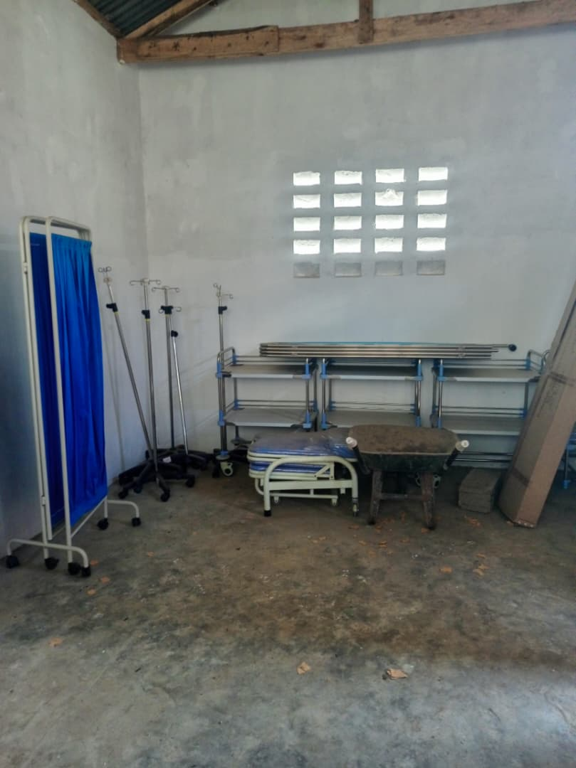
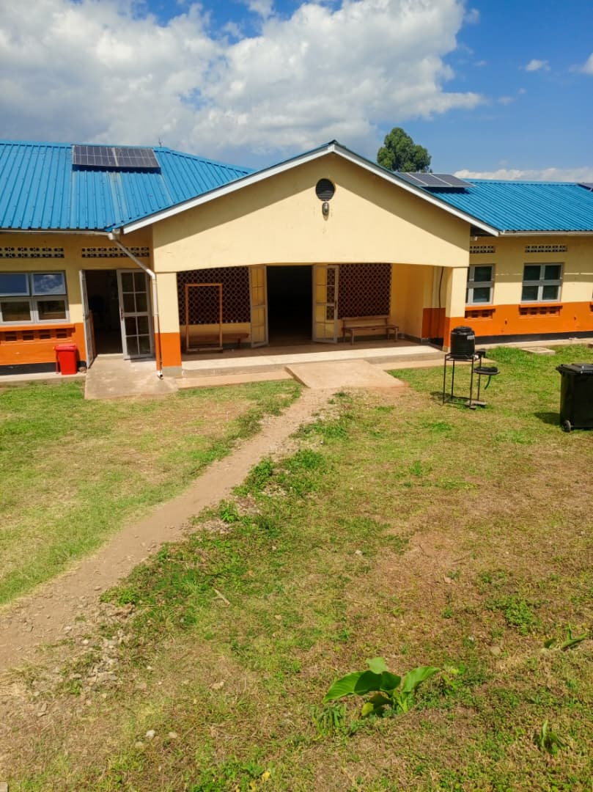
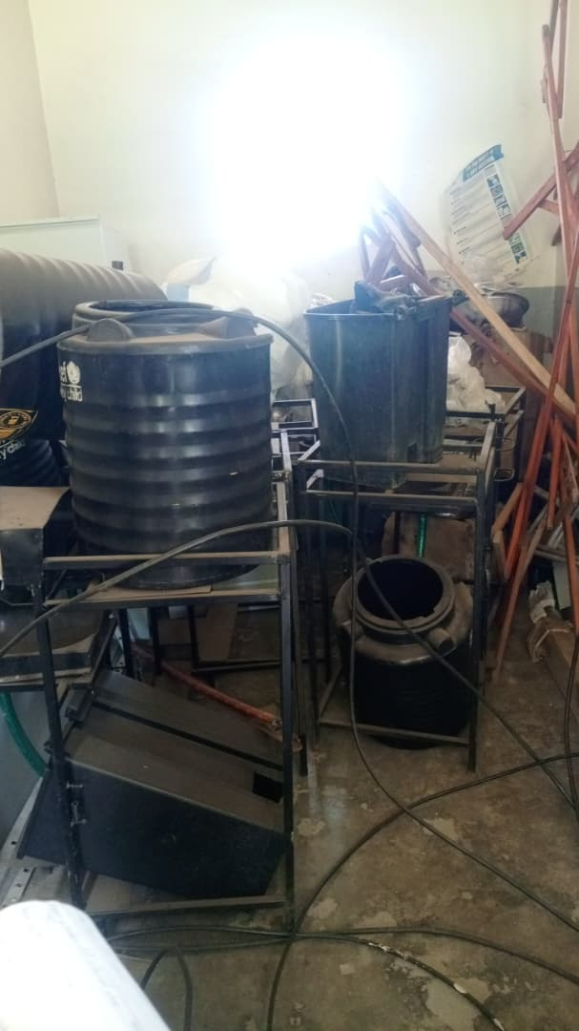
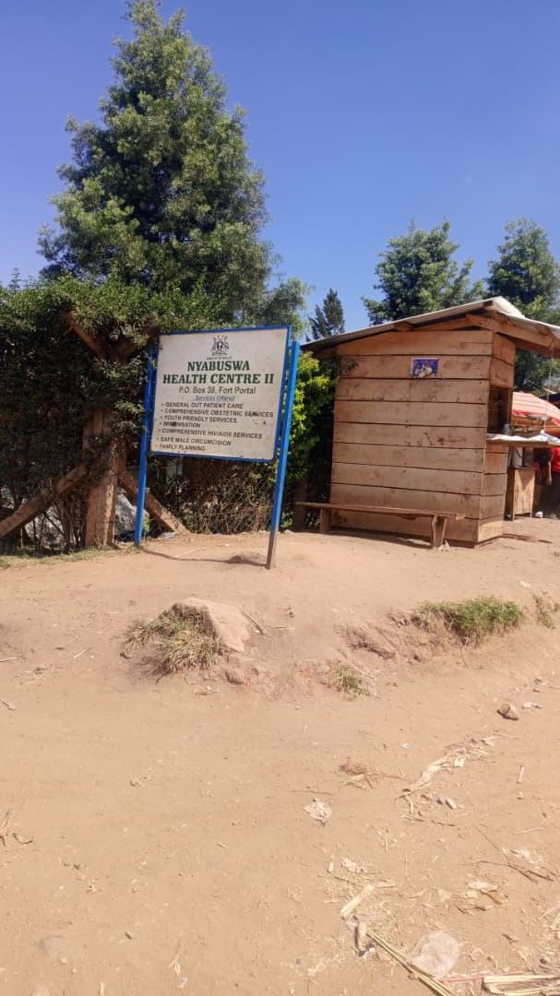

OPD Patient screen, a stretcher & drip stand Signpost Faulty items

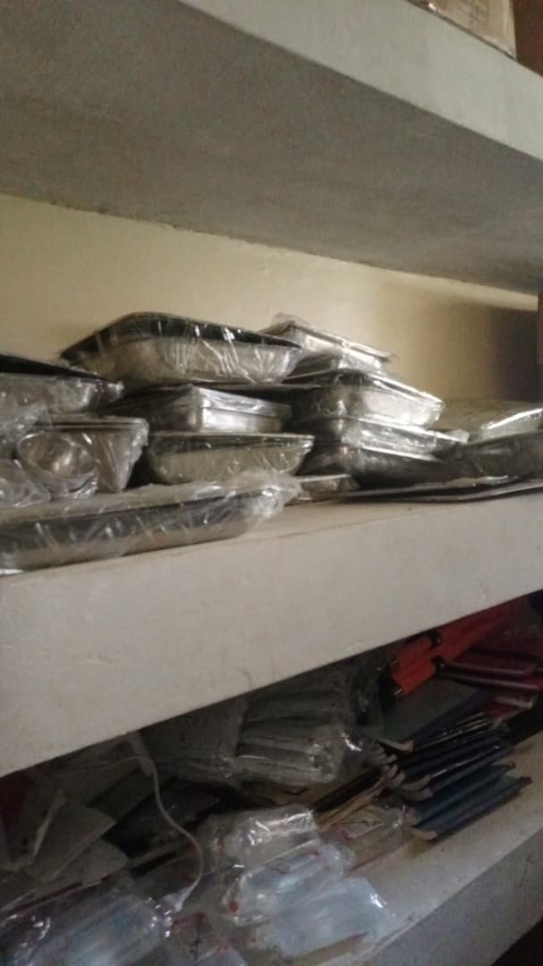
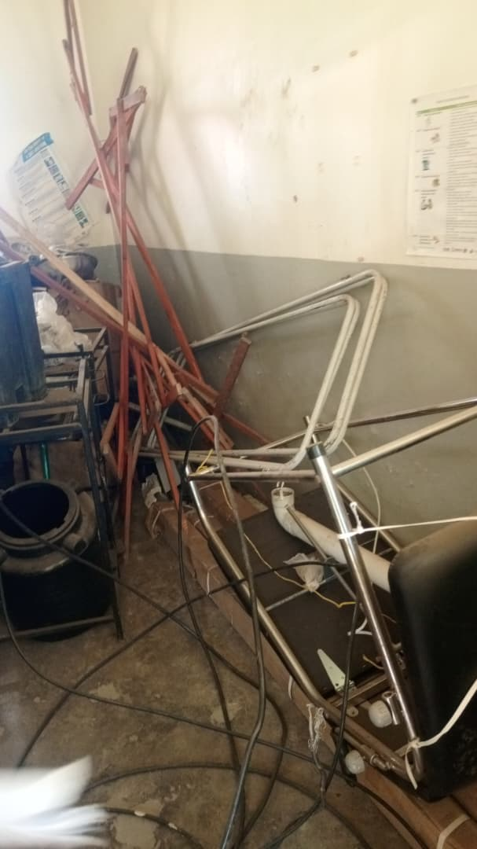
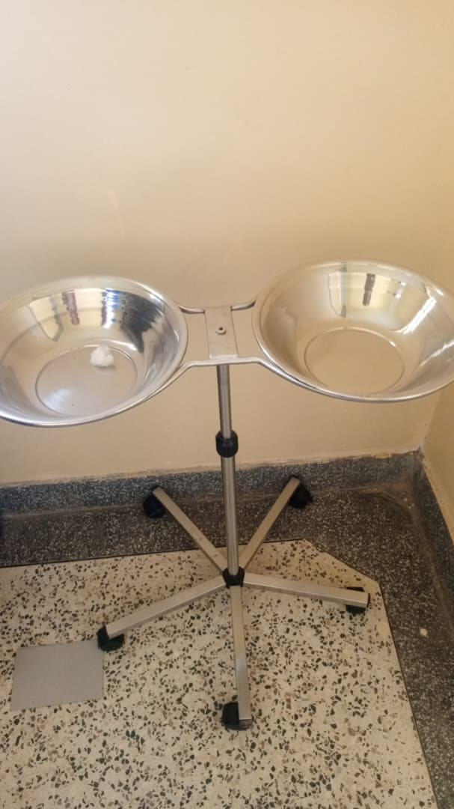
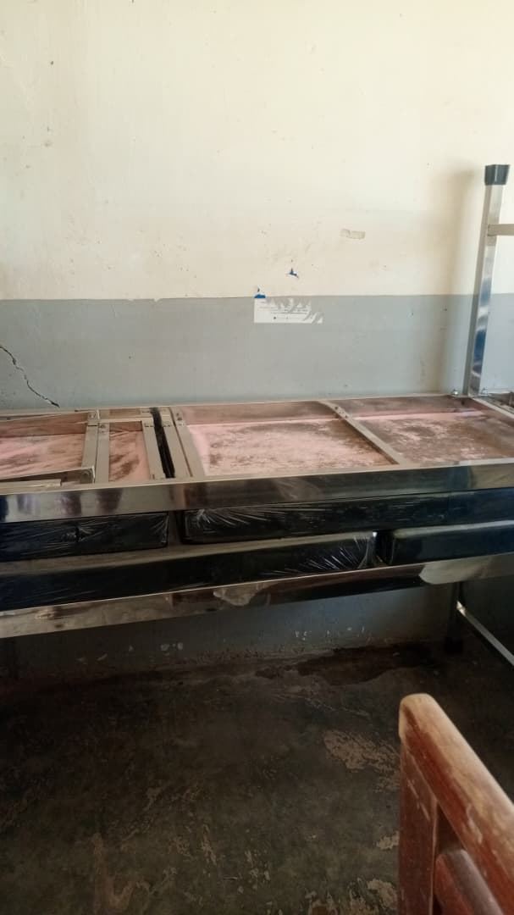

Examination couch Bowl stand Faulty items Instruments
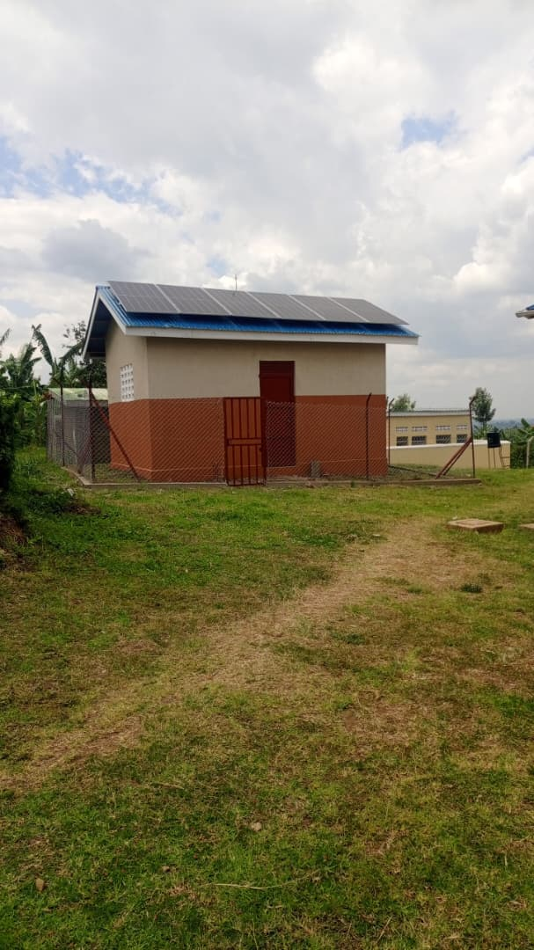
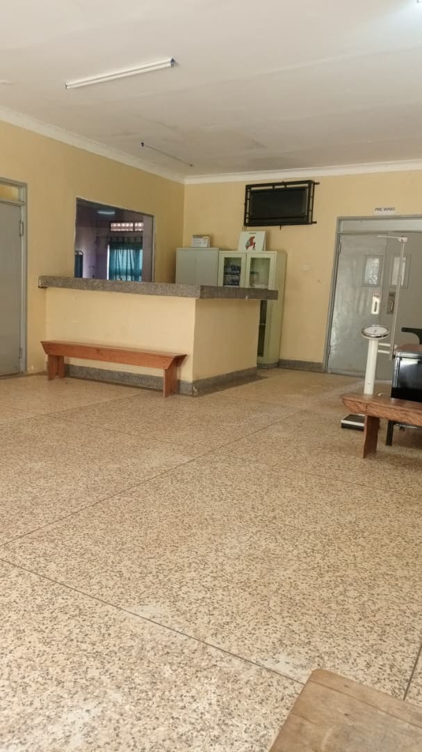
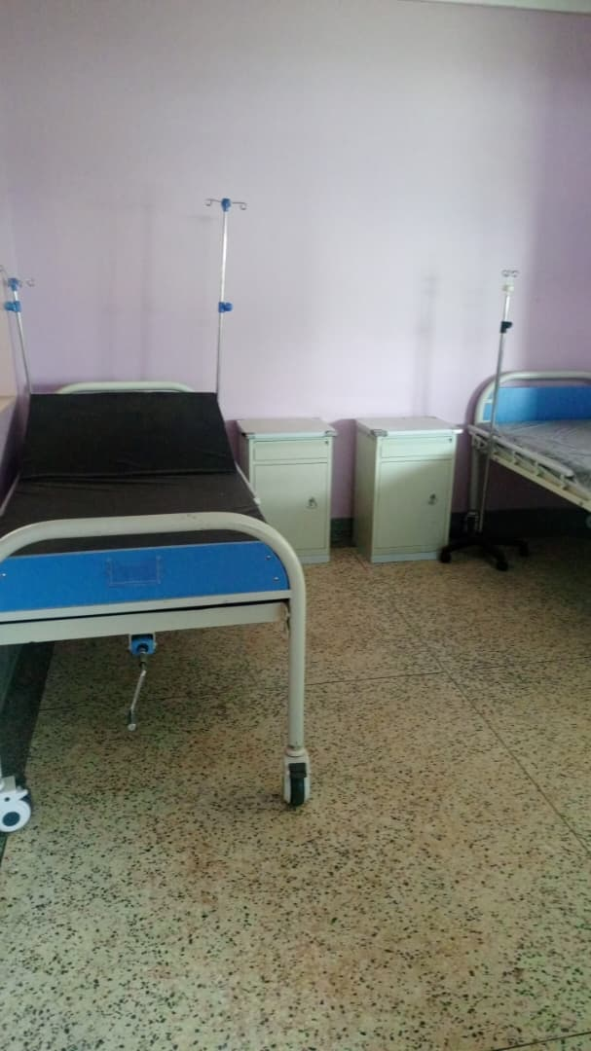

Patient
Bed with Reception
a drip
stand Power house

SCHOOL VERIFICATION CHECKLIST

SCHOOL INTERVIEW/DISCUSSION GUIDE

Name of school: NOMBE SEED SECONDARY SCHOOL

1a | Does the Facility have a record of all assets provided under UgIFT.  (Obtain a record and verify if it has the costs and numbers supplied | Yes, but it has no costs.
1b | If Not ask how many were supplied and when. | 426. he is not sure of the exact date.

2 | How does this facility Maintain (repair/service/replace) the assets provided under Ugift

The facility uses the school budget to repair/service/replace all the assets provided under UgIFT.

3 | Does the facility take regular record about functionality/ or breakdown of the assets provided?  Nonfunctional/ working, and reasons for non-functionality. | Yes. The desks were broken (some)

4 | How has the UgIFT support helped in service delivery in the area, any issues, challenges and any recommendations for better program implementation.

- Source of employment opportunities to the community.
- Provides education as a service to the community which has been led to its development.
Recommendations: If possible Ugift should provide more laboratory equipments and the ICT equiments for the students.
Also they are requesting for a boarding section to be constructed because a lot of children come from very far so they reach at school very late.

PROCEED TO VERIFICATION AFTER THIS DISCUSSION

SCHOOL FURNITURE
(School Desks, Office chairs, Laboratory stools, Book shelves)

Name of LG: NTOROKO DISTRICT Name of SCHOOL: NOMBE SEED SECONDARY SCHOOL

Equipment/ Item | Department | Asset Number | Item  Description | Life in Months | Tag Number ( engrave no.) | Date Of Pur | Date Placed In Service | Recoverable cost | Cost | Acc Dep Cost | Net Book Value | Ytd Deprn | Equipment status | Remarks
School desks | Education |  | Wooden and brown in colour |  |  |  |  |  |  |  |  |  | Two desks  were  faulty and  the rest were  in good  condition | They are in use.  100 desks received.
Office chairs | Education |  | Brown in colour. 9 were black with wheels. Some were maroon in colour with spongy seats and metallic seats. |  |  |  |  |  |  |  |  |  | Good condition | All are in use.  They are 161
Labaratory stools | Education |  | Brown in colour with metallic stands. |  |  |  |  |  |  |  |  |  | Good condition | They are all in use.  They are 120.
Bookshelves | Education |  |  |  |  |  |  |  |  |  |  |  |  | Were not constructed.
Tables | Education |  | Wooden and brown in colour |  |  |  |  |  |  |  |  |  | Good condition | They are all in use. They are 26 tables.

ICT ITEMS TO VERIFY
(Desktop Computer, Server Processor, Network Switch 24 Port, Multipurpose Printer, UPS, Projector, Air Conditioners, Server, CCTV Camera)

Name of LG…………………………………………………………………………… Name of SCHOOL………………………….………………………………………

Equipment/ Item | Department | Asset Number | Item  Description | Life in Months | Tag Number ( engrave no.) | Date Of Pur | Date Placed In Service | Recoverable cost | Cost | Acc Dep Cost | Net Book Value | Ytd Deprn | Equipment status | Remarks
ICT ITEMS |  |  |  |  |  |  |  |  |  |  |  |  |  | They never received any ICT items

BUILDINGS TO VERIFY
(Non- Residential and Residential, Kitchen, Toilets/Pit latrine Water tanks, Fences etc.)

Name of LG…………………………………………………………………………… Name of SCHOOL………………………….………………………………………

Equipment/ Item | Department | Asset Number | Item  Description | Life in Months | Tag Number ( engrave no.) | Date Of Pur | Date Placed In Service | Recoverable cost | Cost | Acc Dep Cost | Net Book Value | Ytd Deprn | Equipment status | Remarks
Non residential | Education |  | Painted cream and white |  |  |  |  |  |  |  |  |  | Good condition | They are in use. They are seven in number.
Residential | Education |  | Painted cream and white |  |  |  |  |  |  |  |  |  | Good condition | They are all in use.  They are 3 in number.
Kitchen | Education |  |  |  |  |  |  |  |  |  |  |  |  | Not built.
Toilets | Education |  |  |  |  |  |  |  |  |  |  |  |  | Not constructed
Pit latrine | Education |  | They are painted cream and white. |  |  |  |  |  |  |  |  |  | Good condition | They are all in use.  They are all in use.  3 are for residential and 3 are not for residential.
Water tanks | Education |  | They are black in colour |  |  |  |  |  |  |  |  |  | One is faulty and two are working. | Two in use. They re three. Not constructed.
Fence |  |  |  |  |  |  |  |  |  |  |  |  |  | Not constructed.

